Canva Tips
How to Open a Canva Template
- Choose the appropriate template from the list and select it.
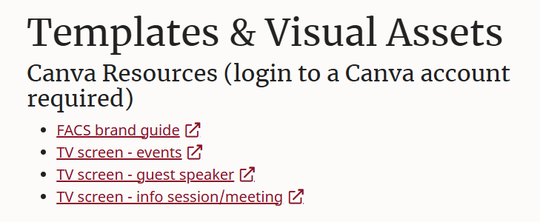

- The below screen will appear – select “Use template for new design.”
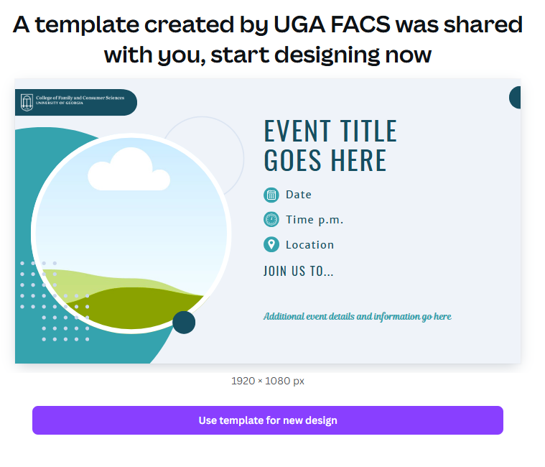
- This will then prompt you to login to Canva with your existing account, or create one if needed. Anyone can create a Canva account for free to use these templates. It is suggested to “continue with email.”
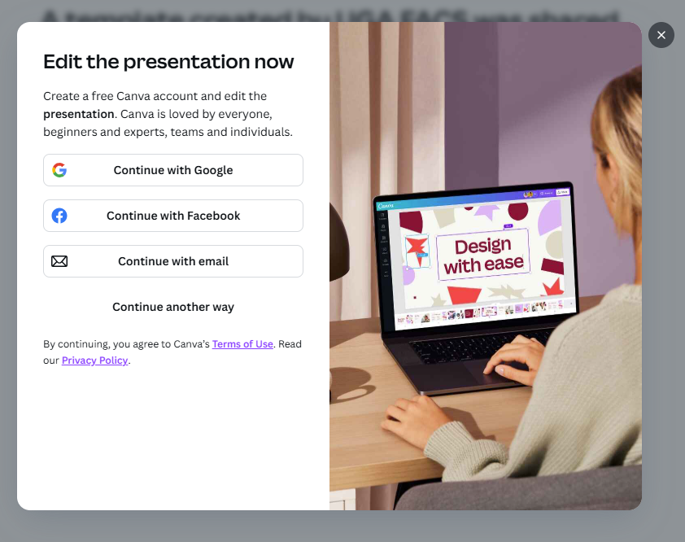
- Once you have logged in/signed up, the template will open and you can choose from any of the options provided. Most templates provide an example of what a finished slide might look like.

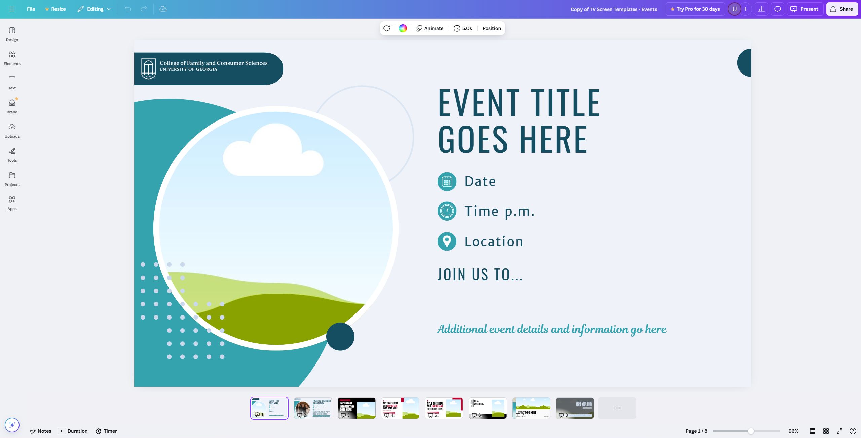
Template options found here

How to Upload an Image
- With your document open, select the “uploads” button on the left side of the screen.
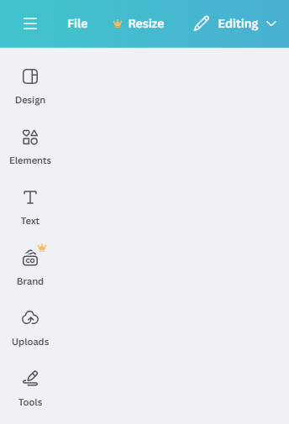

- When the panel opens, select the purple “upload files” button. This will open your computer’s file explorer.
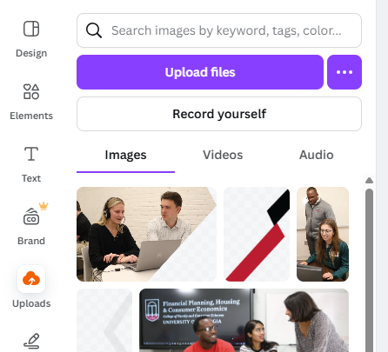

- Choose your image and select the “open” button in the bottom right corner. Your image is now uploaded and should appear at the top of the image gallery.

- Click on your image to add it to your document, or drag the image into the image placeholder.

How to Resize an Image Inside a Placeholder/Frame
- Double click the image you would like to resize – the full view of the image will appear.

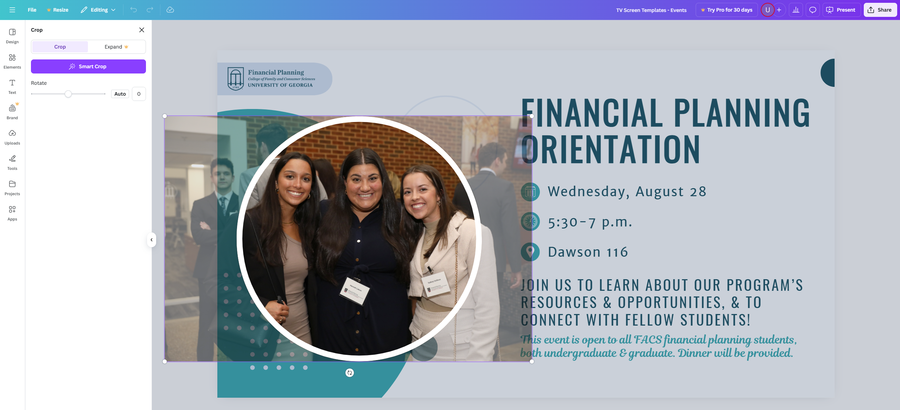

- Use the white dots on the corners of the image to increase or decrease the size.

- Use your cursor to move the image left/right/up/down to best fit the frame, and click anywhere outside the image when finished.

How to Download Your File
- Once your design is complete, select the “share” button in the top right corner.

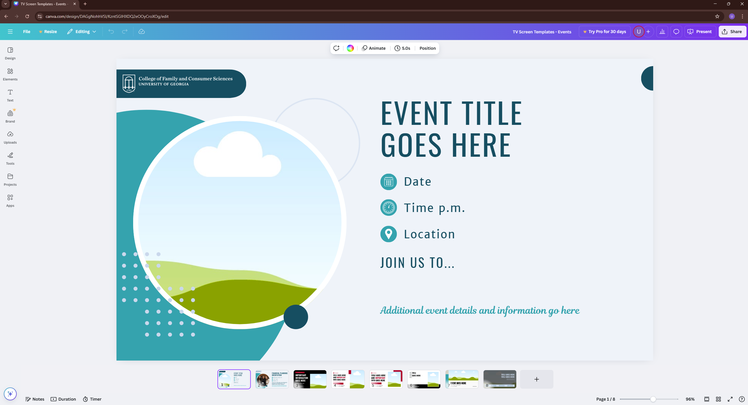

- When the panel opens, select “download” and change the file type to png.

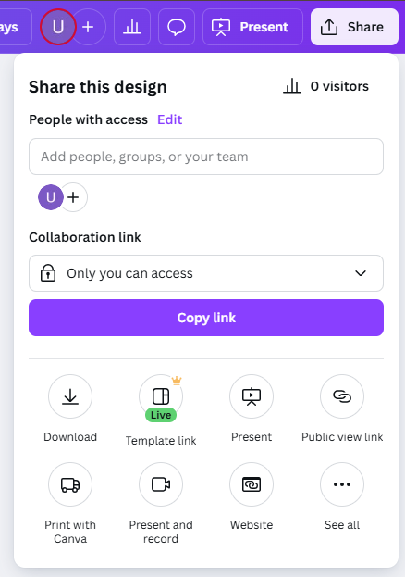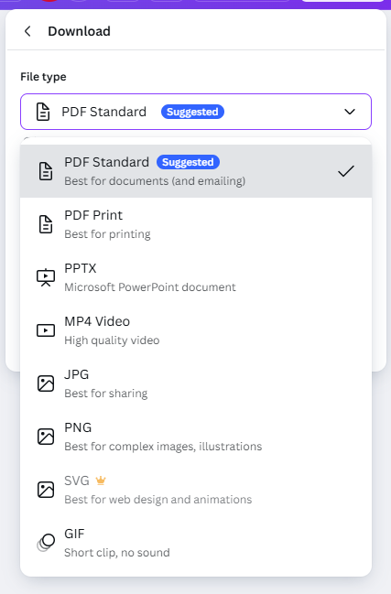

- Use the “select pages” drop down menu to select “current page,” then select “done.”

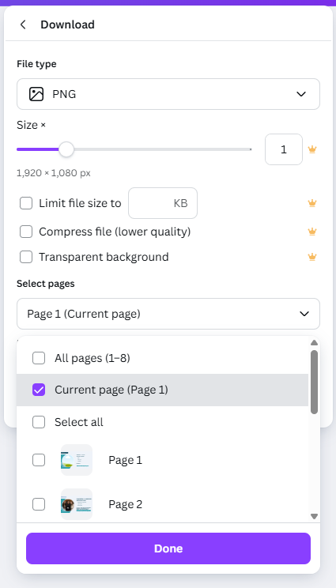

- Select “download” and the image will be located in the downloads folder of your device.

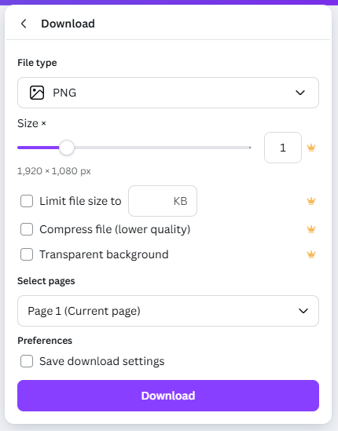
If you have additional questions or encounter any issues, please contact Brandi Herrin at brandi.herrin@uga.edu.

