Sample Competency-Based Behavioral Interview Questions
Competencies are knowledge, skills, abilities, and other characteristics (KSAO’s) that contribute
to individual success in the organization; they focus on “how” things get done. Competencies
help drive individual and organizational performance. UGA’s core competencies apply to all
staff employees and include Integrity, Communication, Learning, Decision Making,
and Service. These core competencies have been identified as critical for all levels of staff
employees to demonstrate on a consistent basis for individual and organizational success. Two
additional competencies have been identified as critical for staff in supervisory and/or
organizational leadership roles. These include Supervision and Innovation.

Competency-based questions should be combined with job function specific and skills related
questions to ensure the most comprehensive interview experience for both the candidate and
committee/hiring authority. See the Interviewer Inquiry Guide for guidance on
permissible/impermissible inquiries.

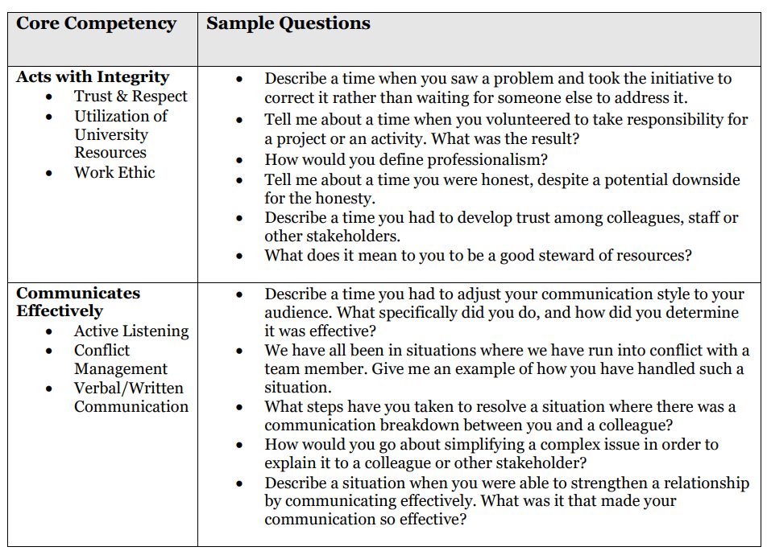

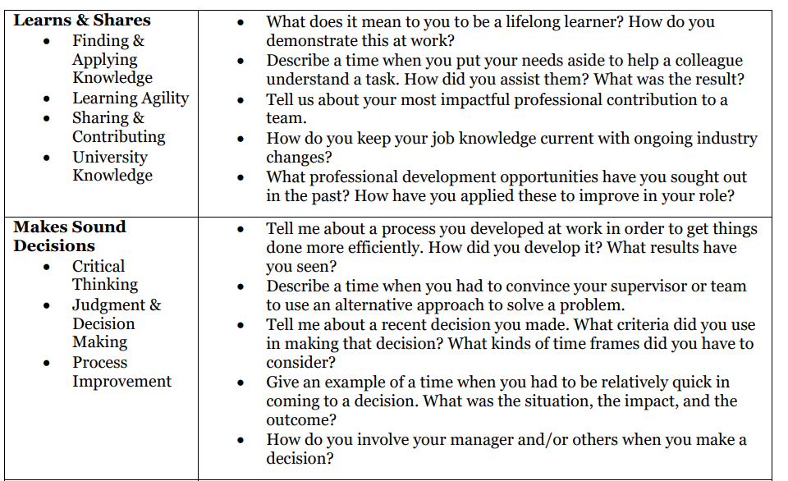
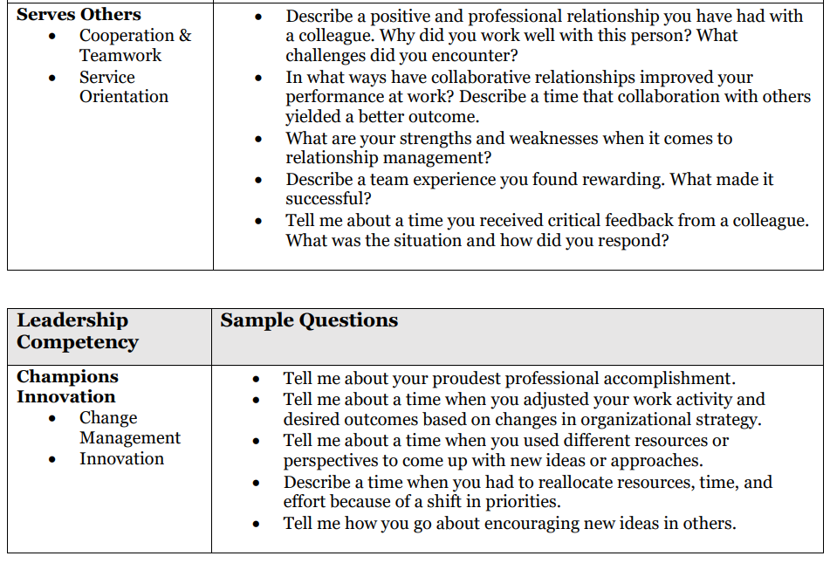

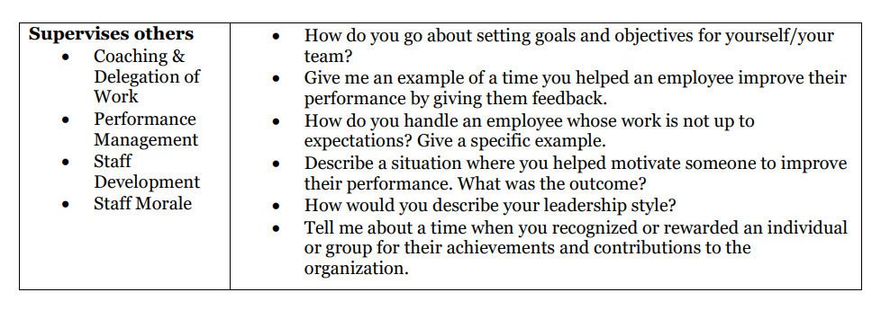

This list of questions is not exhaustive, and is intended to serve as a general guide. For more assistance with interview questions, reach out to facshr@uga.edu.

