
FACS Student Organizations Handbook



Student Success and Advising Center
112 Dawson Hall
(706) 542-4847
success@uga.edu

https://www.fcs.uga.edu/ssac/student-organizations
Updated October 20, 2025
​​
​Introduction
Our college is known for developing leaders through academics, but many of the skills used to chart your career path are curated by your involvement in a student organization. FACS—specifically the Student Success and Advising Center (SSAC)—is here to support you in your role as a student leader and organizational advisor.
The SSAC provides college-related information and serves as a liaison with the newly formed UGA department of Engagement, Leadership, and Service (ELS), a unit of the Tate Student Center within the Division of Student Affairs. ELS brings together the Center for Student Activities and Involvement and the Center for Leadership and Service.
While ELS is a separate entity from FACS, but we collaborate with them in their mission to offer programs, services, events, and learning experiences that strengthen students’ connection to the University, cultivate a sense of community, and empower students as contributing leaders. They are a key resource for all UGA-registered student organizations.
Your main point of contact is SSAC Office Manager Hannah Orsag. Dr. Green serves as the SSAC Director. Additionally, you may communicate with Julie Hawkins in the FACS Office of Finance and Human Resources regarding reports and budget balances.
Other questions regarding SAF funds can be directed to Stacy Minie (stacy.mclaine@uga.edu) in the Student Affairs Business Office or answered on their informative webpage: Student Affairs Business Office.
- If you have an agency account, contact Becca Sattler (rbr09101@uga.edu) in the SABO for information on who supports your organization.

Contact Information
Hannah Orsag – Administrative Associate/Office Manager - hannah.orsag@uga.edu or success@uga.edu
- Hannah supports student organizations with reimbursements, re-registration, student activity fee allocation, handbook updates, and programming to promote student involvement in the College. You may occasionally hear from the FACS Office of Finance and Human Resources.
- Emails from our office are typically important and time-sensitive — please respond promptly. Contact us if you have any questions, especially regarding reimbursements.
Julie Hawkins – Finance and Operations Manager for the SSAC – hawkinsj@uga.edu
- Julie assists with SAF budgeting, expense tracking, and reporting. Monthly budget reports will be sent to treasurers and/or presidents to keep your organization updated on expenditures and balances.
- For any questions about budgeting or reporting, contact Hannah or Julie by email.
Dr. Bernard Green – success@uga.edu
- Dr. Green co-plans the Fall Leadership Retreat for student leaders and advisors and provides leadership and guidance to the student organization support team.
Note: If you're unsure about any process, please reach out. We're here to support your organization, and this document may not cover every situation.

Important Links
FACS
- FACS Student Organization Information
- FACS Web Development
UGA
- UGA Student Organization Resources with the Department of Engagement, Leadership, and Service (ELS)
- https://involvement.uga.edu/studentorg/resources
- Campus Advertising
- Campus Reservations, Events, and Technical Services
- Solicitation (Fundraising) Request Form
- Annual Student Organization Training Modules
- Involvement Network
- Student Affairs Business Office

FACS Student Organizations at a Glance
The Student Success and Advising Center serves as a liaison between the College of Family and Consumer Sciences and the Department of Engagement, Leadership, and Service. We’re here to support your organization. We want you to have what you need to be a successful group. Our goal is to empower students through their organizations to make an impact on and off campus.
For a list of all FACS student organizations, click here.
What We Do – Student Success and Advising Center
- Provide oversight and support to student organizations
- Facilitate reimbursement process for purchases made with allocated Student Activity Fee Funds to student organizations
- Update TV screens with organizational announcements such meetings/events
- Reserve space in Dawson Hall and Barrow Hall
- Reserve tables for tabling in Dawson Hall
- Put up flyers (email success@uga.edu for approval to post one flyer by Dawson 1st floor vending)
- Co-plan fall leadership retreat
What You Do – Student Officers
- Register your student organizations with the UGA department of Engagement, Leadership, and Service (ELS).
- Be familiar with policies related to be in good standing as a student organization
- Review your budget regularly
- Update SSAC when new officers are elected when requested
- Make reservations
- Join the ELS listserv (ugaels@uga.edu)
- Update your FACS webpage with officer information, meetings dates, other events, and pictures. (Maintain your webpage).
What Do You Do – Faculty or Staff Advisors
- Attend student organizations meetings
- Check in with student officers regularly
- Understand budget and reimbursement process
- Make sure your student orgs update contact information, websites, complete annual register student organization
- Attend events and utilize resources by the department of Engagement, Leadership, and Service

Timeline for Student Organizations
Summer
- Table during orientation resource fairs
- Reserve rooms for fall meetings/events (after July 1)

Fall
- Attend FACS Back to School Student Organization Meeting (when needed)
- Attend FACS Annual Leadership Retreat
- Reserve rooms for spring meetings/events
Spring
- Register student organization for upcoming year
- Attend FACS End of Year Student Organization Meeting
- Submit paperwork to be a recognized organization and/or college allocated funding
- Update new officer information
- Update website

To Do & Know
Utilize your resources. Bookmark the FACS Student Organizations page and become familiar with the Resources and Forms tab.
Student Organization Registration
- Student organizations must register annually with the UGA department of Engagement, Leadership, and Service. Registration of student groups is necessary before University facilities and services will be available.
- NOTE: The FACS deadline is always earlier than the ELS deadline and requires additional documentation. Please plan accordingly before the spring semester ends.
- An updated constitution is required for all FACS student organizations.
- Registration information is available under Important Links.
Student Fee Budget Allocation
- There is a process to request funds from the college for eligible student organizations listed on the FACS student organizations’ Resources and Forms webpage.
Officer Contact Information
- Update annually when requested in the spring. Available under Important Links section on page 2 of this document. You must access through a UGA email address to edit.

Website Information
A student organization officer or a faculty/staff advisor updates their specific student organization website. If you would like to update your page, follow the instructions below.
How to Update a Student Organization Page
- Go to the organization page (example page) and click on "Edit Page" at the bottom right
- Change anything you'd like
- Click Save and Close
If you do not have permission to edit, create a ticket here https://www.fcs.uga.edu/otis
For more information on website maintenance go here: https://www.fcs.uga.edu/otis/web-development

Graduation Cord Policy
Per the University of Georgia’s Office of the President, along with the Commencement Steering Committee, and supported by the Dean of the College of Family and Consumer Sciences, cords, stoles, and other adornment over graduation attire is reserved for certain student populations.
Official UGA graduation cords are designated only for highest honors—such as first honors and presidential honors—as well as military affiliation, including veteran status and ROTC membership. This approach is intended to preserve the tradition at UGA of awarding official cords only to recognize select areas of distinction and accomplishment.
We encourage student groups who wish to pursue recognitions to explore pins, certificates, tassel charms, or other such items.
Questions regarding this policy should be directed to Dr. Melissa Landers-Potts, Interim Associate Dean for Academic Programs – mlpotts@uga.edu

Facility Guidelines
Dawson Hall and Barrow Hall Room Reservation Requests
- If you need to reserve a room inside Dawson or Barrow Hall, submit a request. Allow three business days for processing. Business days are M-F, 8 a.m.-5 p.m. when classes are in session. Your reservation is not confirmed until you receive a confirmation email from success@uga.edu.
- Reservations in Classrooms or spaces outside of Dawson or Barrow Halls go through Campus Reservations at reserve@uga.edu. More information can be found at https://tate.uga.edu/campus-reservations/classroom-reservations/reserve-a-classroom/
Building Information
- All entrance doors to Dawson and Barrow Halls automatically lock between the hours of 6pm to 7am, weekdays.
- Do not prop or hold doors open, as this will cause the alarm to go off and will automatically call the UGA police department. This means that the doors may not remain open longer than the natural closing of the door. This includes interior foyer doors as well.
- For after hours and weekend special events, contact Casey Crane (casey.crane@uga.edu) to schedule availability of the handicap access door off the parking lot and loading ramp.
- The Departmental Offices, located on each floor in Dawson, are responsible for locking the classrooms on their respective floors at 5 PM. It is the responsibility of the student organization to verify with the Departmental Office that the room will be unlocked for the meeting the day of.
Departmental Offices:
- 1st Floor: Human Development & Family Science Room 123
- 2nd Floor: Financial Planning, Housing & Consumer Economics Room 210
- 2nd Floor: Nutritional Sciences, Room 280
- 3rd Floor: Textiles, Merchandising & Interiors Room 321
Dawson Hall Tabling Reservation Requests
- If you need to reserve a table for Dawson Hall, submit a request. Allow three business days for processing. Business days are M-F, 8 a.m.-5 p.m. when classes are in session. Your request is not confirmed until you receive a confirmation email from success@uga.edu.
- Student organizations usually table to promote awareness about the organization or an upcoming meeting or event.
- To “table” in Dawson Hall, the SSAC will provide you with a table but your organization is responsible for providing all other items.
- If you are fundraising, selling tickets, or exchanging money it MUST be approved by the Dean of Students Business Office. Tables are permitted inside Dawson Hall only in designated areas. Tables cannot leave Dawson Hall premises.
  - To reserve a table in Dawson Hall, submit your reservation requests through the reservations button found on the Resources and Forms page of the FACS Student organizations website: https://www.fcs.uga.edu/ssac/student-organizations
  - Your reservation is not confirmed until you receive a confirmation email from success@uga.edu.
  - Requests should be made at least 5 business days ahead of the event. More notice should be given if it is an important event for your organization.
  - Please allow 3 full business days for processing. Business days are M-F, 8am-5pm when classes are in session.
Campus Reservations
- For all other campus reservations, you must submit a reservation request through the https://tate.uga.edu/campus-reservations/ website.
Room Usage Guidelines
Please help us keep our facilities clean, safe, and ready for class by following these guidelines:
- Clean up after yourselves and your guests.
- Food is not allowed in any computer labs or other labs in Dawson or Barrow.
- If your organization is having an event involving food, it is your responsibility to clean up AND take the trash to the dumpster following the event. The custodial staff empties the trash on a daily basis. However, they might have already emptied the trash prior to your event, and are not responsible for anything left over after the event. Thanks for helping to keep Dawson Hall clean!
- Do not remove any furnishings or equipment from the room.
- Following the conclusion of student organization meetings or events, move all desks, chairs, tables, and white boards back to their original position. It is crucial that all rooms are clean and orderly for class the following day.
For All FACS Student Organizations
Venues and Contracts: When securing a venue for an event where a contract is required, you must work with the University Procurement office adhering to policies, completing forms, and meeting deadlines (theirs and the College’s).
Financial Information
Account Information
Student organizations are allowed to have two accounts as follows:
- Student Activity Fee Allocated College Account and Agency Account (both through UGA)
- Agency Account (UGA) and Non-University Banking Account (like SunTrust, BOA, etc.)
Student organizations may have both a student activity fee allocated college account and an agency account, but if so, the organization may not have any outside checking account. Student organizations must have written approval from the dean in order to have both allocated and agency accounts.
Send allocated account questions to success@uga.edu.

Agency Accounts
An agency account is a special University account, available to officially registered student organizations which do not receive state or student activity fee funding. Income for the organization is usually generated from dues, donations, fund raising activities, and ticket sales.

- Agency accounts are fully supported by the Tate Student Center Business Office only
- Agency accounts can spend 100% on travel and food
- Agency account funding automatically carry-forward into the next FY

Student organizations which choose to maintain an agency club account with the Business Office will be required to pay applicable taxes on purchases. All ticket sales, as well as goods and services sold by the Tate Student Center on behalf of student organizations, are subject to sales tax.

Direct agency account questions to the Student Affairs Business Office (sabo@uga.edu). Their office is in room 126 in the Tate Student Center. Their main phone is 706-542-8514.

Non-University Bank Accounts
A non-university account is any account not associated with the University of Georgia such as Wells Fargo, Chase, Bank of America, etc. If you have a non-university banking account, financial related information in this handbook does not pertain to you. All other policies apply such as selling tickets on campus, reserving rooms, being registered, etc do. If you have an outside checking account, we cannot help you resolve any issues. Employees of the University of Georgia are strictly prohibited from acting as a signatory on the private bank account of any of the University’s student organizations. The full policy is available at this link - https://policies.uga.edu/Human-Resources/Employment/non-university-bank-accounts/.
Student organizations are prohibited from maintaining private bank accounts if they receive a Student Activity Fee allocation. Organizations affiliated with schools or colleges are permitted to have an Agency Account through the Student Affairs Business Office.

Student Activity Fee Allocated College Accounts
The college allocation is an amount given to a student organization. They receive a line item allocation from the Student Activity Fee award amount provided to the College of Family and Consumer Sciences. The student organization must put in a budget request for approval of the funds needed.
Student organizations which receive a student activity fee allocation are exempt from the payment of Georgia Sales Use Tax and Federal Excise taxes. However, many vendors will routinely add sales tax to purchases. When paying a vendor by University payment request, the sales tax should be deducted from the amount due when preparing the check request. If a vendor adds sales tax to a petty cash purchase, the full amount, including the tax, will be reimbursed to the individual who made the purchase.
Funding qualifications
- In order to receive funding for the upcoming year, you must attend the budget allocation meeting in the spring. Information regarding the meeting date and time will be shared mid-spring semester from success@uga.edu.

- To qualify for funding, each student organization must register annually with the department of Engagement, Leadership, and Service (ELS).
For All UGA Accounts
Reimbursements
To submit reimbursements for student allocated funds, please complete the following steps and submit to the Student Success and Advising Center in 112 Dawson Hall in person or email at success@uga.edu.
Complete the vendor registration information at https://suppliers.uga.edu which includes the address where you will receive payment.
Complete and submit a non-employee payment form.
Complete and submit a justification for food purchase form if food was included in the expenses.
Submit original, itemized receipt(s) with completed form(s) and a printed flyer, email, or other posting of the event that includes date, time, and name of organization.
Note: Examples of how to complete the non-employee payment form and justification for food purchase form are shown in the FACS Handbook for Student Org Leadership and Advisors.
If you have an agency account, all support will be with the Student Affairs Business Office in the Tate Center.
- Note: If you are unsure if expenses meet with the guidelines, please check with Hannah beforehand to avoid out-of-pocket expenses. See Appendices # 2 & 3 for forms.
Budget Requests
- All expenses must comply with USG and UGA policies and procedures as well as student activity fee guidelines

For Student Activity Fee Allocated College Accounts
Links:
- Student Activity Fee Fund Guidelines
- Policy
Student Activity Fee funds may be used to fund food, student travel, and promotional purchases for registered student organizations as part of a sponsored program or event. However, the total spending for the three categories cannot exceed a combined value of 40% of the total Student Activity Fee Allocation Budget. It is not a requirement to make a purchase in each category. Organizations can spend 100% of their Generated Income on Food, Student Travel, and Promotional Items.
- For example, a registered student organization who receives a Student Activity Fee Allocation may spend 35% of their budget on Food, 5% of their budget on Promotional, and 0% of their budget on Travel = 40% Combined Allowance from the budget.
Expenditures for Food
All food purchases must comply with the university’s food policy, including any applicable per diems.
Expenditures for Student Travel
Student Activity Fee funds may be used to support student travel to conventions, conferences, and competitive team events. However, travel expenses must be specifically requested and included in the budget for any program or activity funded wholly or partially by Student Activity Fee funds. Allowable expenses may include reasonable costs for transportation, lodging, and meals associated with attendance as a delegate or representative.
Allocation recommending committees may establish guidelines that limit the number of participants funded for a single event, the number of trips supported, and the maximum reimbursement amounts. These guidelines may also specify which types of travel expenses are eligible for funding. All travel reimbursements must comply with applicable University travel expense policies and limits.
Individuals seeking to use allocated accounts for student travel expenditures must receive pre-approval and supply requested information in a process developed by Student Affairs Business Office.
A maximum daily allowance for meals will be $50.00 (recommended as $13.00 for breakfast, $14.00 for lunch, and $23.00 for dinner). For out-of-state travel, the GSA rates for per diem will apply. Itemized meal receipts must be submitted for reimbursement.
Travel proposals should not exceed the 40% combined allowance of the Student Activity Fee Allocation. Exceptions may be made when student travel is a significant element of the organization’s mission and purpose. These requests must be made at the time the budget is presented to the Student Activity Fee Allocation Committee. Registration fees are not included when calculating the 40% combined allowance spending limit.
No increase in the Activity Fee portion (not to include generated income) of the travel budget will be allowed during the fiscal year without the expressed permission of the Office of the Vice President for Student Affairs through the Student Affairs Business Office.

Expenditures for Promotional Items/Marketing Tools
These items are associated with promoting student organizations (signs, displays, tablecloths with logos, etc.) and/or events sponsored by student organizations and must include the name and/or logo of the sponsoring student organization or the event.
All promotional items must be pre-approved via the UGAmart purchasing process. Acceptable purchases include pens, phone wallets, notepads, cups, etc. The value of the promotional item should not exceed $30. All printed promotional items including t-shirts, polos, other apparel must be purchased through UGAmart as well as the acceptable purchases previously listed. Promotional items should not exceed the 40% combined allowance of the annual SAF Allocation.
- If you generate income during the year, organizations may spend 100% of the revenue taken in on food and travel.

- Funds remaining in the allocated account at the end of the fiscal year will be recalled to the Student Activity Reserve & Surplus account

- Any student fee allocated organization who generates income from fundraising, dues, tickets must deposit all receipts though the Student Affairs Business office in the Tate Center.

- Compensation for Services Provided by Individuals: Individuals that provide services to an organization (such as speakers, entertainers, lecturers, etc.) can be paid for their services rendered. If the organization does not want to pay the individual with money (a check), they can be paid with an item. The value of the item should be $100 or less. All items purchased for this purpose must be pre-approved via the UGAMart purchasing process.

- Gifts/Awards: Generally, purchasing gifts and awards is not allowable using Student Activity Fee funds. In the following special circumstances, these purchases are allowed:
  - Annual Recognition: Gifts/awards purchased for one-time annual recognition for student members are allowable. All gifts/awards purchased for this purpose must be pre-approved in UGAMart. Acceptable purchases include plaques, frames, or certificates. The individual value of the gift/award should not exceed $30/item. Under no circumstances should gift cards or clothing/apparel items be purchased for this purpose.

- Conference registrations don’t count toward 10% travel allocation rule

- These funds cannot be used for scholarships or gift cards; book purchases are allowable.

- Cannot use Student Activity Fees for fundraising, but can host events using alternative funding (must charge a fixed price and any funds remaining can be donated to charity, just remember to take out expenses before donation)

- No Equipment purchases over $100, payment for equipment maintenance is allowable. All equipment must be purchased via UGAMart.

- The Student Affairs Business Office provides a detailed list of Processes, Tips, and Reminders.

Note: All reimbursements/payments must be approved, not just entered, within 2 weeks of original purchase.

Student Travel
Please check with Hannah Orsag in the Student Success and Advising Center regarding any travel that your organization may interested in at least two months in advance.
Student Travel Forms must be filled out before you travel. Any trip that is off-campus is considered travel. You will not be reimbursed for any travel expenses without the proper paperwork being filed. Make sure to review the travel policies on the Student Affairs website to ensure you are eligible for reimbursement.
Per UGA Travel Policy, On-line booking services, such as AirBnb, VRBO, HomeAway, and other similar type service providers is prohibited. If you use one of these providers, you WILL NOT be reimbursed.
Travelers should not book non-refundable rates or rates that require a deposit unless required by conference lodging. It is the traveler or arranger’s responsibility to understand the cancellation rules of the room confirmed. No-show charges and penalties will not be reimbursed when the traveler does not cancel reservations within the allotted time. Non-refundable rates cannot be changed or cancelled; therefore, the traveler is accepting the risk of a non-reimbursable cancelation fee.
Fundraising
- Requests to fundraise on campus must be submitted online to the department of Engagement, Leadership, and Service at least 10 business days in advance of the event. The Solicitation (Fundraising) Request Form is available on the ELS website.
- All approved fundraisers will be assigned a permit via an e-mail from the Involvement Network. This e-mail will serve as your permit, which must be printed and displayed at your event, and will include a permit number.
Advertising
FACS
- TV Screens/Digital Signage: If a student organization would like to advertise information on the monitors in Dawson and Barrow Halls, create a PowerPoint slide. Email it to Brandi Herrin (bnh07450@uga.edu) and include the start date of the PowerPoint’s appearance on the TV screens in Dawson. Text should be able to be read in 10 seconds or less.
  - Please make sure the slide isn’t text heavy in a difficult to read font. Users should be able to read and comprehend in 10 seconds or less. If you have questions about what is acceptable contact Brandi Herrin, FACS Public Relations Associate, at bnh07450@uga.edu.
  - More information is available here - https://www.fcs.uga.edu/otis/building-screens-signage

- FACS Connection News Digest: A monthly digest sent to all undergraduate FACS students. Items for FACS Connection should be submitted by 5:00 p.m. on the 25th of each month. Instructions on formatting a FACS Connection entry can be found here.
- Promotional Materials: (fliers, handouts, etc.). Can only go in designated spaces by 1st floor vending machines. If put up in unauthorized areas, they will be removed and discarded. The Advertising Guidelines & Restrictions policy for posting in Dawson Hall is available in Appendix # 1 of the handbook.
- FACS Website: Events & Calendar entries
- If you have access to Expression Engine you can add your own. If not, contact Jimmy Hansen at jphansen@uga.edu.
- Speak in your FACS classes: Ask your instructor for permission ahead of time
- Tabling: You can promote events in Dawson Hall. Refer to the facility guidelines section on how to reserve.
- FACS Social Media: if you’d like something posted on FACS Social media, contact Brandi Herrin (bnh07450@uga.edu)
Campus
For other ideas, visit the Campus Advertising under Important Links on page 2. Student organizations must refer to ELS website to be familiar with the guidelines and policies related to advertising on campus.

Logos and Trademarks
Information regarding logo use can be found here. Any intended use of the University of Georgia name, logo, or other trademarked emblems on merchandise, whether it is to be sold or given away, must be approved. Contact Brandi Herrin at bnh07450@uga.edu with any questions and to make sure your materials are in compliance.

ANY use of the University of Georgia name, logo, or other trademarked emblems (regardless of whether it’s sold) must be approved by the UGA Marketing and Communications trademarks department at trademarks@uga.edu. The direct link to the logo approval form is here: https://brand.uga.edu/wp-content/uploads/uga-logo-approval-form.pdf.

ALL t-shirt/apparel/uniforms/promotional items purchased, with or without logos, must be initiated through UGAMart. This applies to any type of university account, including agency accounts. This will ensure that all proper approvals (trademark in particular) have been taken care of before the order is placed.

Please note this covers all orders even if you think no trademarks are involved. You WILL NOT be reimbursed for t-shirt/apparel/uniforms/promotional items purchases made outside of the UGAMart system.

To begin and coordinate this process, contact Hannah Orsag in the Student Success and Advising Center before you initiate the buying process with vendors.

APPENDICES
Appendix 1 – Advertising Guidelines & Restrictions Policy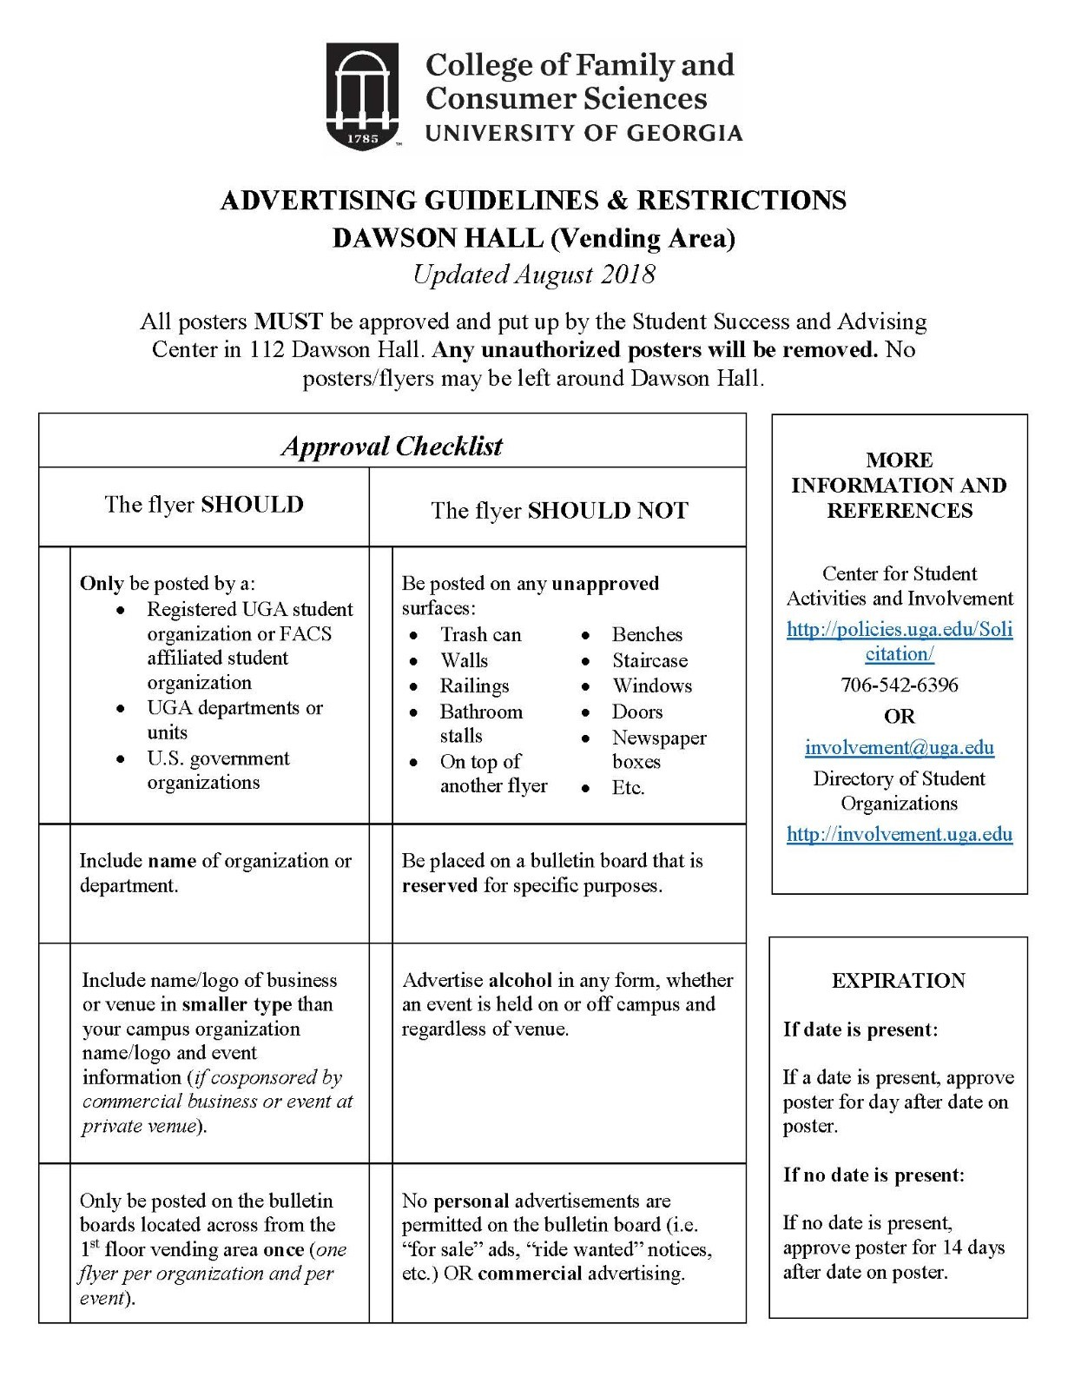

Appendix 2 – Non-Employee Payment Form
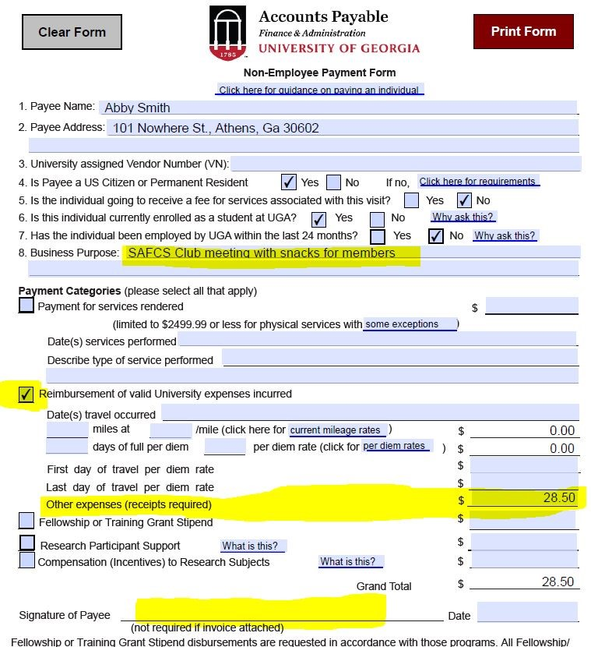

Appendix 3 – Justification for Food

