Dear Community Advisory Council member,
IHDD needs your help in sharing information about a Georgia statewide needs assessment being conducted by Research and Evaluation Unit at IHDD (REU@IHDD) with your network. The study focuses on collecting information from individuals with Traumatic Brain Injuries (TBI), their family caregivers as well as professionals working with them. They can complete online surveys using the links below as well as participate in our focus groups by completing the focus group interest from.

For your convenience, we have drafted an email narrative that you can copy and send to your network.
Thanks a lot, in advance for your assistance with this!

Email Narrative for Individuals with TBI, family, professional caregivers, state agencies:

The Brain and Spinal Cord Injury Trust Fund Commission (BSITFC) of Georgia is seeking input from individuals with Traumatic Brain Injury (TBI) and/or their caregivers about the services and support needs, and gaps in services, related to TBI in Georgia. Through grant funding from Administration on Community Living (ACL), the BSITFC is working with the Research and Evaluation Unit (REU) at the IHDD, UGA.

You can participate in the need assessment by completing a survey or participating in a focus group.

1) SURVEYS
The survey should take approximately 10-15 minutes to complete, and your participation is completely voluntary.

Surveys can be found by going to the Needs Assessment web page. Once you are on the page, please click on the big red icons to select the survey you want to complete.

Surveys can also be ​accessed by clicking on any of the links below. You can also copy and paste the URL in your web browser. There are three different surveys. You can select a survey based on what you identify with the most.

a. Survey for individual with TBI and/or caregiver

b. Survey for professionals working with individuals with TBI

c. Survey for Georgia state agency personnel

QR CODES: You can also scan the QR codes to access the survey relevant to you.

Survey for Individuals with TBI, family caregivers
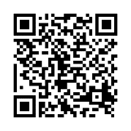

Survey for Professionals working with individuals with TBI
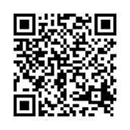

Survey for Georgia State Agency personnel
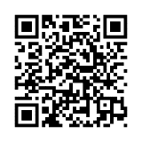

2) FOCUS GROUPS
We are also conducting focus groups to hear more from individuals with TBI and their caregivers about their service needs and barriers. If you would like to participate in a focus group, please click on the text or scan the QR code below to complete the form and someone will contact you about your participation.

Participate in Focus Group

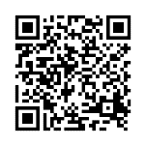

Note: For the purpose of this study, Traumatic Brain Injury (TBI) is defined as a form of acquired brain injury, that occurs when a sudden trauma causes damage to the brain. TBI can result when the head suddenly and violently hits an object, or when an object pierces the skull and enters brain tissue. Symptoms of a TBI can be mild, moderate, or severe, depending on the extent of the damage to the brain.

If you have questions or need more information about the needs assessment, please send an email to researchevaluation.ihdd@gmail.com. In advance, thank you for your time and participation!

Hamida Jinnah, PhD.
Associate Research Faculty
Research and Evaluation Unit (REU) Director
Institute on Human Development and Disability-UCEDD
The University of Georgia
850 College Station Rd
Athens GA 30605
Phone: (706) 542-3968
hamida@uga.edu

